Traffic Sign Recognition Using a
From-Scratch Feed-Forward Neural Network
A study of the German Traffic Sign Recognition Benchmark using a multi-layer perceptron implemented without machine learning frameworks
A Project Report Submitted in Partial Fulfilment of the Requirements for the Degree of Master of Science

Author: Bibek Ghimire
Institution: [fill in institution name]
Supervisor: [fill in supervisor name]
Submission Date: [fill in submission date]

Status of This Document
All sections are complete. Section 7 reports results from training runs performed on 26 September 2026: the E0 baseline and every ablation, E1–E6, 17 runs in total, each with a single seed (1). The trained models, logs, metric files and figures behind every number are in the results/ folder of the repository.
Results are single-seed, so differences of about one percentage point between configurations are within noise (Section 9.5). E5 was run through a float32 input wrapper because the unmodified code ran out of memory (Section 7.4).

Abstract
Traffic sign recognition is a core perception task in driver assistance and autonomous driving, and one where the cost of a misclassification is asymmetric: mistaking a speed limit sign for another speed limit sign is a different kind of failure from missing a stop sign entirely. This report presents a traffic sign classifier for the German Traffic Sign Recognition Benchmark (GTSRB) — 51,839 images across 43 classes — built on a fully connected feed-forward neural network implemented from first principles in NumPy. No machine learning framework is used: forward propagation, backpropagation, the Adam optimizer, inverted dropout, L2 regularization, He initialization and early stopping are each derived and implemented directly.
The contribution is not benchmark performance. A fully connected network operating on flattened pixels lacks both translation invariance and any notion of spatial locality, and is therefore structurally disadvantaged against the convolutional architectures that define the state of the art on this dataset. The contribution is instead a complete, inspectable and reproducible implementation of the underlying mechanics, together with an experimental design that isolates the contribution of each component — initialization scheme, optimizer, regularizer, network depth and data augmentation — and an honest characterisation of where the architecture's ceiling lies and why.
A methodological finding is reported independently of any training run: three transformation choices inherited from the digit-recognition domain are demonstrably invalid for traffic signs. Horizontal mirroring, standard in digit and general-object augmentation, systematically produces mislabelled examples for the eight directional sign classes in GTSRB, since a mirrored “Turn left ahead” is a valid image of “Turn right ahead” carrying the wrong label.
Keywords: traffic sign recognition, GTSRB, multi-layer perceptron, backpropagation, Adam optimization, dropout, data augmentation, class imbalance

Table of Contents
(This field updates automatically in Microsoft Word: right-click anywhere in the table below and choose “Update Field,” or press Ctrl+A then F9.)

1. Introduction

1.1 Background
Automatic traffic sign recognition sits in the perception layer of advanced driver assistance systems and autonomous vehicles. The task is superficially easy — signs are standardised, high-contrast, and designed by regulation to be legible at distance — and in practice hard, because the images a vehicle actually captures are degraded in ways the designers never intended: motion blur, low sun, night, rain, partial occlusion by foliage, faded or vandalised faces, and severe perspective distortion when a sign is approached off-axis.
Stallkamp et al. [1] established the German Traffic Sign Recognition Benchmark in 2011 to make these methods comparable. Their headline result is worth restating, because it sets the bar: human classification accuracy on GTSRB is 98.84%, and the best submitted machine learning system exceeded it at 99.46%, using a committee of convolutional neural networks [2]. Traffic sign recognition is thus one of the earliest vision tasks on which machines demonstrably surpassed human performance.

1.2 Problem Statement
Given a cropped image containing exactly one German traffic sign, assign it to one of 43 classes. This is a closed-set, single-label classification problem. It is explicitly not detection: locating signs within a full street scene is a distinct problem requiring a different class of model, and is out of scope (see Section 9.2).

1.3 Motivation for the Approach
Modern frameworks make it possible to train an accurate classifier without understanding what the training loop does. That convenience has a cost in educational settings: the gradient computation, the optimizer's state, the behavioural difference between dropout at training and at inference time — all of it is behind an API.
This project takes the opposite approach deliberately. Every component is implemented in NumPy and can be inspected, unit-checked, and reasoned about line by line. The accompanying notebook (Project_Walkthrough.ipynb) executes each stage of a training step in isolation so that the intermediate tensors are directly observable.
The cost of this choice is accepted openly: the architecture cannot compete with a convolutional model on this dataset. Section 8.4 quantifies why, and Section 10.2 sets out the path to closing the gap.

1.4 Objectives
- Implement a complete multi-layer perceptron in NumPy — forward propagation, backpropagation, Adam, dropout, L2, He initialization, early stopping and learning rate scheduling — with no machine learning framework.
- Build a preprocessing pipeline that adapts GTSRB's variable-size, variable-exposure colour photographs into fixed-length feature vectors.
- Design and specify a controlled experimental protocol isolating the effect of each architectural and training choice.
- Evaluate with metrics appropriate to an imbalanced multi-class problem, rather than accuracy alone.
- Establish which augmentation transformations are valid in the traffic sign domain, as opposed to inherited unexamined from other image domains.
- Deliver the whole thing reproducibly: pinned dependencies, a container definition, and a documented single-command path from clean checkout to trained model.

1.5 Scope
In scope: classification of pre-cropped single signs; grayscale preprocessing; fully connected architectures; the training and regularization methods listed above; offline data augmentation; per-class evaluation.
Out of scope: sign detection or localisation; video and temporal tracking; convolutional, recurrent or attention-based architectures; real-time embedded deployment; colour-channel modelling (see Section 9.1).

1.6 Contributions
- C1. A complete framework-free implementation of a trainable MLP, documented to the level of individual equations (Section 4).
- C2. A GTSRB preprocessing pipeline with each stage justified against a specific property of the data (Section 4.2).
- C3. A domain analysis of augmentation validity, identifying horizontal mirroring as label-corrupting for this dataset and correcting two transformation ranges inherited from the digit domain (Section 4.9).
- C4. A controlled experimental protocol of six ablations (Section 5.4).
- C5. Three defects identified and corrected in the antecedent digit-recognition codebase, two of which are silently wrong rather than loudly wrong (Section 4.10).
- C6. Measured resource characterisation of the training procedure (Section 5.1).

2. Related Work

2.1 The Benchmark and Its Results
GTSRB was introduced as a competition at IJCNN 2011 [1]. The final standings are instructive about what matters on this task:
Rank | Method | Accuracy | Note
1 | Committee of CNNs [2] | 99.46% | Ensemble of 25 networks
2 | Human performance [1] | 98.84% | Measured over 32 test subjects
3 | Multi-scale CNN [3] | 98.31% | Features from multiple layers to the classifier
4 | Random forests | 96.14% | On HOG features
5 | LDA on HOG | 95.68% | Classical baseline

Two things follow. First, convolutional architectures dominate the top of the table decisively. Second, even the classical HOG-based methods clear 95%, which sets a meaningful reference point: a method that cannot beat LDA on HOG features is not exploiting the structure of the problem.

2.2 Classical Approaches
Before CNNs, GTSRB systems were pipelines of hand-designed features and a conventional classifier. Histogram of Oriented Gradients (HOG) [4] was the dominant descriptor, capturing local edge orientation statistics — well matched to signs, whose identity is largely carried by shape and pictogram outline. Colour segmentation in HSV space was often used as a first-stage filter, exploiting the regulatory colour coding (red for prohibitory, blue for mandatory, yellow for temporary).
The relevance to this work is that these methods succeed by engineering translation robustness into the features. A fully connected network on raw pixels has neither engineered features nor learned translation invariance, which is precisely the deficit analysed in Section 8.4.

2.3 Convolutional Approaches
Ciresan et al. [2] won the benchmark with a committee of deep CNNs trained on augmented data. Sermanet and LeCun [3] introduced a multi-scale architecture feeding both early and late convolutional stages to the classifier, on the argument that traffic sign identity depends on both fine detail (the digits inside a speed limit sign) and coarse shape (the sign's outline). Their result also established that grayscale input costs surprisingly little accuracy on GTSRB relative to full colour — a finding this project's preprocessing relies on (Section 4.2).

2.4 Multi-Layer Perceptrons on Image Data
The theoretical position of the MLP is well established. The universal approximation theorem [5] guarantees that a single hidden layer of sufficient width can approximate any continuous function on a compact domain — so representational capacity is not the binding constraint here. The binding constraint is sample efficiency. A fully connected layer treats input position 100 and position 101 as unrelated coordinates. It must therefore learn the appearance of a sign separately at every position it can occupy, and every such position requires its own training examples. LeCun et al. [6] identified this as the motivation for weight sharing in convolutional networks.
The methods this implementation uses are individually standard: He initialization [7], scaled for the ReLU nonlinearity; the Adam optimizer [8], combining momentum with per-parameter adaptive step sizes; and inverted dropout [9] as a stochastic regularizer.

2.5 Positioning of This Work
This project does not aim to advance the state of the art on GTSRB, and it would be dishonest to present it as doing so. It occupies the pedagogical position: a complete, transparent implementation of the mechanics that frameworks abstract, applied to a real dataset with real difficulties, together with an experimental design that makes the resulting limitations legible rather than mysterious.

3. Dataset

3.1 Description
The German Traffic Sign Recognition Benchmark [1] is published by the Institut für Neuroinformatik, Ruhr-Universität Bochum, under CC BY 4.0.
Property | Value
Classes | 43
Training images | 39,209
Test images | 12,630
Total | 51,839
Format | PPM (uncompressed RGB)
Image dimensions | Variable, 15×15 to 250×250 px
Annotation | Per-image ROI bounding box and class id, semicolon-delimited CSV
Colour | 24-bit RGB
Licence | CC BY 4.0

3.2 Provenance and Structure
Images were extracted from roughly 10 hours of video recorded on German roads. Critically, each physical sign contributes a track of 30 consecutive frames as the vehicle approaches it. Frames within a track are highly correlated: they differ mainly in scale and slightly in viewing angle.
This has a direct methodological consequence. Randomly splitting the training set into training and validation partitions places frames of the same physical sign on both sides of the split, so validation accuracy is optimistically biased. The official train/test partition is track-disjoint and does not suffer from this; the internal dev split used here does. This is recorded honestly as a threat to validity in Section 9.3 rather than glossed over.

3.3 Class Distribution
The dataset is materially imbalanced. Training images per class range from 210 (class 0, “Speed limit 20”) to 2,250 (class 2, “Speed limit 50”) — a ratio of roughly 10.7:1. The distribution reflects real-world sign frequency rather than sampling error, which is arguably the right choice for a benchmark but makes accuracy a poor headline metric (Section 6.1).
Figure 3.1 — Class distribution histogram. Generated by visualize_data_distribution(train_y, "training").

3.4 Sources of Difficulty
Source | Description | Mitigation in This Work
Illumination | Tunnels, direct sun, dusk, headlights | Histogram equalization (§4.2)
Scale | 15×15 to 250×250 px | Resize to fixed 32×32 (§4.2)
Motion blur | Vehicle in motion | Blur augmentation (§4.9)
Perspective | Off-axis approach | Partially, via rotation and shift (§4.9)
Occlusion | Foliage, stickers, poles | Not addressed
Inter-class similarity | Speed limits differ only in digits | Architectural limitation (§8.4)
Class imbalance | 10.7:1 | Reported per class (§6); not corrected
Physical degradation | Fading, vandalism, damage | Not addressed

The three “not addressed” entries are stated deliberately. They are known weaknesses of this system, not oversights.

4. Methodology

4.1 System Overview
The pipeline moves from a raw, variable-size RGB image with an annotated region of interest, through a five-step deterministic preprocessing stage, into a three-layer fully connected network (1024 → 512 ReLU → 256 ReLU → 43 softmax), producing a probability distribution over 43 classes together with a second-choice prediction.
The implementation is four modules with a strict acyclic dependency order: dataset.py → data_augmentation.py → model_utils.py → ffnn.py. dataset.py has no project dependencies and owns everything from acquisition to encoding. ffnn.py contains only the network and depends on nothing but model_utils.py.
Data representation. All matrices are column-major: the design matrix X (1024 × m) has features down the rows and examples across the columns, and labels Y (43 × m) likewise. A mini-batch is therefore a contiguous column slice, and the forward pass is a single matrix product per layer with no transposition.

4.2 Preprocessing
Each image undergoes five deterministic transformations. Each is justified against a specific property of GTSRB rather than adopted by convention.
1. Crop to the annotated ROI. GTSRB supplies a bounding box per image; the raw file carries approximately 10% background margin beyond it. Since a fully connected network assigns an independent weight to every input coordinate, that margin is 20–30% of the input budget spent on pixels containing, by construction, no signal. The crop reclaims it.
2. Convert to grayscale. Retaining RGB triples the first layer's parameter count — from 524,288 to 1,572,864 weights at the default width — for information that is largely redundant with shape. Sermanet and LeCun [3] report that grayscale costs little accuracy on GTSRB. This is a considered trade-off, not a free choice, and Section 9.1 records what it gives up.
3. Histogram equalization. The highest-value step in the pipeline for this dataset. GTSRB's illumination range is extreme, and equalization redistributes each image's intensity histogram towards uniform, so that a tunnel exposure and a noon exposure of the same sign present comparable inputs. Without it the network must devote capacity to learning illumination invariance from data.
4. Resize to 32×32 bilinear. A fixed input dimension is required. 32×32 is chosen as the smallest size retaining the pictogram detail that separates visually adjacent classes, at 1,024 features. 28×28 (the MNIST convention) degrades speed limit digits; 48×48 raises the first layer to 1.18M weights for marginal detail gain.
5. Flatten and scale. (32,32) → (1024,1), divided by 255 to place every feature in [0,1]. Unnormalised inputs in [0,255] produce first-layer gradients two orders of magnitude larger than later layers', which forces a learning rate too small for the rest of the network.
Labels are one-hot encoded to a length-43 vector.

4.3 Network Architecture
An L-layer fully connected network with widths [1024, h₁, …, hₗ₋₁, 43]; the default is [1024, 512, 256, 43].
Layer | Shape of W | Shape of b | Parameters | Activation
1 | (512, 1024) | (512, 1) | 524,800 | ReLU
2 | (256, 512) | (256, 1) | 131,328 | ReLU
3 | (43, 256) | (43, 1) | 11,051 | Softmax
 |  | Total | 667,179

ReLU is used on hidden layers for its non-saturating gradient; softmax on the output to produce a normalised distribution over the mutually exclusive classes.

4.4 Weight Initialization
He initialization [7] draws each weight from a zero-mean normal distribution with variance 2 / nᵀ⁵ᵃᶻₘᵉᵛʰ, and initialises every bias to zero.
W^(l) ~ N(0, 2 / n^(l-1)), b^(l) = 0
The factor 2/n⁽ˡ⁻¹⁾ preserves activation variance across a ReLU layer. Since ReLU zeroes half its input in expectation, halving the variance, the factor 2 compensates; without it, activation magnitude decays geometrically with depth and deep networks train slowly or not at all. Biases start at zero because the weights already break symmetry.
The alternative implemented for comparison is W ∼ 0.01·𝒩(0,1), a depth-independent scale. Experiment E1 (Section 5.4) quantifies the difference.

4.5 Forward Propagation
For l = 1 … L−1, with A⁽⁰⁾ = X:
Z^(l) = W^(l) A^(l-1) + b^(l), A^(l) = max(0, Z^(l))
and at the output layer, softmax is applied column-wise with the maximum subtracted for numerical stability:
Z^(L) = W^(L) A^(L-1) + b^(L), Y_hat_{k,i} = exp(Z_{k,i} - max_j Z_{j,i}) / Sum_c exp(Z_{c,i} - max_j Z_{j,i})
The subtraction of the column maximum is a numerical necessity, not a refinement: raw logits of even modest magnitude overflow the exponential in double precision. Subtracting the maximum leaves the softmax mathematically unchanged while bounding every exponent at zero.
Caching. Each layer stores (A⁽ˡ⁻¹⁾, W⁽ˡ⁾, b⁽ˡ⁾) and Z⁽ˡ⁾ on the forward pass. Backpropagation requires exactly these; recomputing them would double the cost of a training step.

4.6 Loss Function
Categorical cross-entropy over m examples:
J = -(1/m) Sum_i Sum_k Y_{k,i} log Y_hat_{k,i}
Since Y is one-hot, only the true class contributes: the loss is the negative log-probability assigned to the correct answer.
Computation from logits. Evaluating log(softmax(z)) in two steps risks log(0) once the network becomes confident and a probability underflows to zero. The implementation instead uses the algebraically equivalent but numerically stable form
log y_hat_k = z_k - max_j z_j - log Sum_c exp(z_c - max_j z_j)
which cannot underflow. This is why the caches retain Z rather than only A. With L2 regularization the objective gains a penalty term λ/(2m) · Σₗ ‖W⁽ˡ⁾‖²_F.

4.7 Backpropagation
At the output layer, the softmax and cross-entropy derivatives compose to the simple form dZ⁽ᴸ⁾ = Ŷ − Y, which is why the softmax branch of the backward activation is an identity pass-through. Then for l = L … 1:
dW^(l) = (1/m) dZ^(l) A^(l-1)^T + (lambda/m) W^(l), db^(l) = (1/m) Sum_i dZ^(l)_{:,i}, dA^(l-1) = W^(l)^T dZ^(l)
and through the ReLU, dZ⁽ˡ⁾ = dA⁽ˡ⁾ ⊙ ퟙ[Z⁽ˡ⁾ > 0].
Shape assertions. Every gradient must match the shape of its parameter, and this is asserted at the point of computation. NumPy broadcasting will silently produce a wrongly-shaped but valid array from a transposition error, and the resulting failure surfaces many layers later as poor convergence rather than as an exception. Asserting at the source converts a silent bug into a loud one.

4.8 Optimization
Adam [8] maintains per-parameter first and second moment estimates:
v_t = beta1 * v_{t-1} + (1 - beta1) dW_t, s_t = beta2 * s_{t-1} + (1 - beta2) dW_t^2
Both are initialised at zero and are therefore biased towards zero early in training; the bias-corrected estimates ᵛ̂_t = v_t/(1−β₁ᵗ) and ŝ_t = s_t/(1−β₂ᵗ) give the update:
W_t = W_{t-1} - alpha * v_hat_t / (sqrt(s_hat_t) + epsilon)
Defaults β₁ = 0.9, β₂ = 0.999, ε = 10⁻⁸. The counter t increments per mini-batch, not per epoch, and is never reset — the bias correction is defined in terms of the number of updates applied.
Three alternatives are implemented for comparison: batch gradient descent (mini-batch = m), stochastic gradient descent (mini-batch = 1), and mini-batch gradient descent without adaptivity. Learning rate scheduling is available as an optional decay applied every k epochs, floored at 10⁻⁴.

4.9 Regularization
Inverted dropout [9]. During training each hidden activation is multiplied by a Bernoulli mask and divided by the keep probability:
A^(l) <- (A^(l) elementwise* D^(l)) / p, D^(l)_{ij} ~ Bernoulli(p)
The division is what makes the scheme inverted: it preserves E[A⁽ˡ⁾], so inference requires no compensating rescaling — dropout is simply not applied. The same masks are reused in the backward pass, so a dropped unit receives no gradient. Dropout is applied to hidden layers only, never to the output.
L2 regularization, as given in Section 4.6, penalises weight magnitude. The two are treated as alternatives, not combined.
Early stopping. Dev accuracy is evaluated each epoch; parameters are checkpointed whenever it improves, and after P epochs without improvement training halts and the best parameters are restored rather than the last.

4.10 Data Augmentation
Five transformations are implemented: random rotation, random shift, blur (Gaussian, maximum, minimum, median or uniform), zoom, and crop-and-pad. Each pass produces five variants per source image.
Domain validity of transformations (contribution C3). The transformation set was inherited from a hand-written digit recognition system, and three choices proved invalid when re-examined for traffic signs:
Transformation | Digit Setting | Traffic Sign Setting | Reason
Horizontal flip | Used | Removed | Signs are not chirality-invariant. A mirrored “Turn left ahead” (class 34) is a valid image of “Turn right ahead” (class 33) but retains the label 34. This manufactures mislabelled training data for eight directional classes.
Rotation | ±60° | ±15° | A digit at 40° is still that digit. A sign at 40° is a photograph that does not occur; capacity spent on it is wasted.
Shift | ±7 px on 28×28 (25%) | ±3 px on 32×32 (9%) | Post-ROI-crop the sign fills the frame; a 25% shift translates a substantial fraction of it out of view.

The horizontal flip case is the substantive one. It is not a tuning preference but a label-correctness error, and it is silent: training proceeds normally and the damage appears only as depressed accuracy on the affected classes. The function is retained in the codebase with a documented warning and is never invoked by the generator.
Defects corrected in the antecedent codebase (contribution C5). Three further issues were found and fixed:
- precision() and recall() divided by zero for any class the model never predicted, returning NaN and propagating it into the macro average. With 43 classes and a long tail this is the expected case, not an edge case. Corrected to score 0.
- blur_images(filter_mode="random") — the documented default — fell through its dispatch chain to a ValueError. The random branch was reachable only via a second, separate flag.
- Early stopping wrote checkpoints to a temp/ directory in the working directory and left it behind if a run was interrupted. Moved to a managed scratch directory.
Defects 1 and 3 are silent; only 2 announces itself.

5. Experimental Setup

5.1 Hardware and Resource Characterisation
Resource measurements below were taken on a 2-core x86-64 Linux container. Memory figures follow from array sizes and are machine-independent; timings are a conservative upper bound, since the reference machine is deliberately modest.
Quantity | Measured
Training design matrix, (1024 × 35289) float64 | 289 MB
Peak RSS, [1024,512,256,43] | 816 MB
Peak RSS, [1024,1024,512,256,43] | 919 MB
Peak RSS, augmented (6× data) | ~2.5 GB
Time per epoch, [1024,512,256,43] | 7.0 s
Time per epoch, [1024,1024,512,256,43] | 16.1 s
Preprocessing throughput | 7,553 images/s
Model size on disk | ~5 MB

Memory is dominated by the design matrix, not the model: 289 MB of data against 5 MB of parameters. A 40-epoch run at the default architecture therefore completes in roughly 5 minutes on two cores and requires under 1 GB of RAM. No GPU is used or usable: the implementation is NumPy throughout and has no accelerator path.
Measured during the Section 7 runs (2-core x86-64 container, 8 GB RAM). A baseline epoch took 4–10 s, depending on load. E0 early-stopped after 28 epochs in 2 min 50 s, with peak RSS 1141 MB. The deepest E4 network took 10 min 58 s. The augmented run's memory was much higher than the ~2.5 GB estimated above. augment.py peaked at 4.4 GB, and the unmodified train.py --use-augmented was OOM-killed at 5.8 GB. Holding the inputs as float32 brought it to 3.5 GB.

5.2 Software Environment
Component | Version
Python | 3.7+ (3.11 in the container image)
NumPy | ≥1.19
Pillow | ≥8.0
SciPy | ≥1.5 (augmentation only)
Matplotlib | ≥3.3 (visualisation only)

A Dockerfile and docker-compose.yml pin the full environment. No machine learning framework is present, by design.

5.3 Protocol
Partitioning. The official GTSRB train/test split is preserved. A 10% development partition is drawn at random from the training set, giving 35,289 training / 3,920 dev / 12,630 test.
Test set discipline. The test partition is used exactly once, for final evaluation. All model selection, hyperparameter choice and early stopping use the dev partition only. Repeatedly consulting the test set and adjusting in response leaks information and inflates the reported figure.
Seeding. np.random.seed(1) is set at entry to every script. Given identical data and flags, runs are reproducible.

Baseline configuration
Hyperparameter | Value
Architecture | [1024, 512, 256, 43]
Initialization | He
Optimizer | Adam (β₁=0.9, β₂=0.999, ε=10⁻⁸)
Learning rate | 0.001
Mini-batch size | 128
Epochs | 40
Regularization | Dropout, p = 0.8
Early stopping patience | 5 epochs

5.4 Planned Experiments
Each varies one factor from the baseline; all other settings and the seed are held fixed.
ID | Question | Conditions | Command
E0 | Baseline | As above | python train.py --epochs 40
E1 | Does He initialization help? | he vs random | --initialization {he,random}
E2 | Does adaptivity help? | adam vs mgd vs bgd | --optimizer {adam,mgd,bgd}
E3 | Which regularizer? | dropout (p∈{.6,.7,.8,.9}) vs l2 (λ∈{.1,.4,.7,1.0}) vs none | --regularizer ...
E4 | Does depth or width help? | [256], [512,256], [1024,512,256], [1024,512,256,128] | --hidden ...
E5 | Does augmentation help? | With and without 6× augmented data | --use-augmented
E6 | Does LR decay help? | None vs decay every 10 epochs | --step-decay {0,10}

E1 and E2 are expected to show large effects in early epochs and converge later. E3 and E4 trade bias against variance. E5 is the test of the augmentation analysis in Section 4.9. Each configuration should be run with at least three seeds and reported as mean ± standard deviation; single-run differences on this dataset are not reliably distinguishable from seed noise.

6. Evaluation Metrics

6.1 Why Accuracy Is Insufficient
With a 10.7:1 imbalance, a model that performs well on the frequent classes and poorly on the rare ones posts a respectable accuracy. Accuracy is reported for comparability with the literature but is not the headline metric here.

6.2 Per-Class Metrics
For class k with confusion matrix C (rows true, columns predicted):
Precision_k = C_{kk} / Sum_i C_{ik}, Recall_k = C_{kk} / Sum_j C_{kj}, F1_k = 2 * P_k * R_k / (P_k + R_k)
Precision answers “when it says class k, is it right?”; recall answers “of the true class-k images, how many did it find?”. Both denominators can be zero — precision's when the class is never predicted, recall's when it is absent from the split — and both cases are handled explicitly (Section 4.10).
For traffic signs the asymmetry is real: low recall on “Stop” means missing stop signs, which is materially worse than low precision on the same class.

6.3 Macro Averaging
Macro-F1 = (1/43) Sum_k F1_k
The unweighted mean gives a rare class exactly the weight of a common one. Macro-F1 is the headline metric for this work.

6.4 Top-2 Accuracy
The classifier reports a second prediction, obtained by taking the argmax after suppressing the winner. Top-2 accuracy is informative here because several class pairs are near-identical at 32×32: a model frequently right in second place is confusing a specific pair, which is a different and more tractable failure than not perceiving the sign at all.

6.5 Confidence Calibration
Mean softmax confidence is reported separately over correct and incorrect predictions. A well-calibrated model is markedly less confident when wrong, which makes the confidence score usable as a rejection threshold in deployment — a property with direct safety relevance.

6.6 Reported Artefacts
- Overall accuracy, macro-precision, macro-recall, macro-F1
- Per-class precision, recall, F1 (43 rows)
- 43×43 confusion matrix
- Top-1 and top-2 accuracy
- Mean confidence, correct vs incorrect
- Training and dev loss/accuracy curves
- Sample grid of misclassified images

7. Results
All figures in this section come from runs performed on 26 September 2026 in a 2-core x86-64 Linux container (8 GB RAM, Python 3.11, NumPy with OpenBLAS), with the code in this repository unmodified. Every run uses seed 1 and the same 35,289 / 3,920 / 12,630 train / dev / test partition. Each configuration was run once, so differences smaller than about one percentage point should be read as within seed noise (Section 9.5). The raw outputs — logs, trained models, per-run metrics and every figure — are in the results/ folder.

7.0 How Each Item Was Generated
Table 7.0 — Commands
Item | Command
All runs (E0–E4, E6) | experiments/run_all.sh <run-id> … — calls train.py --epochs 40 --no-plot then evaluate.py --no-plot per run
E5 (augmentation) | python augment.py --aug-count 1, then python experiments/train_lowmem.py --use-augmented (see Section 7.4)
Tables 7.1–7.10, Figures 7.1–7.8 | python experiments/analyze.py → results/summary.json, results/*.csv, results/figures/
Error analysis (Section 7.3) | python experiments/error_analysis.py → results/e0_error_analysis.json

7.1 Baseline Performance
Table 7.1 — Baseline (E0) results
Metric | Value
Test accuracy (top-1) | 88.46%
Test accuracy (top-2) | 92.76%
Macro-precision | 0.849
Macro-recall | 0.843
Macro-F1 | 0.841
Training accuracy at restored epoch (23) | 96.71%
Best dev accuracy (restored parameters) | 95.08%
Train–dev gap at restored epoch | +1.63 pp
Final-epoch training / dev accuracy | 97.04% / 94.92%
Epochs completed (of 40) | 28
Early stopping triggered | Yes — no dev improvement after epoch 23; epoch-23 parameters restored
Wall-clock training time | 2 min 50 s
Peak memory (RSS), training | 1141 MB
Mean confidence when correct | 0.950
Mean confidence when incorrect | 0.558
Expected calibration error (15 bins) | 0.021
Test errors | 1458 of 12,630

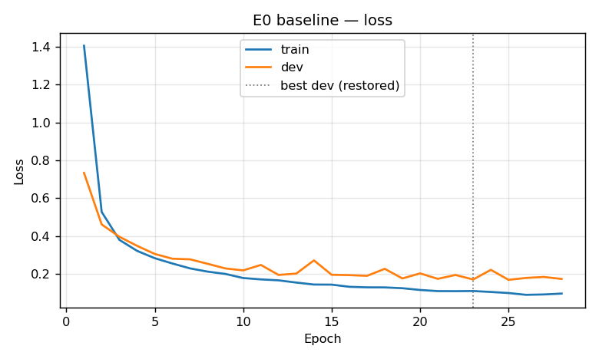
Figure 7.1 — E0 training and dev loss per epoch. The dotted line marks the restored epoch.
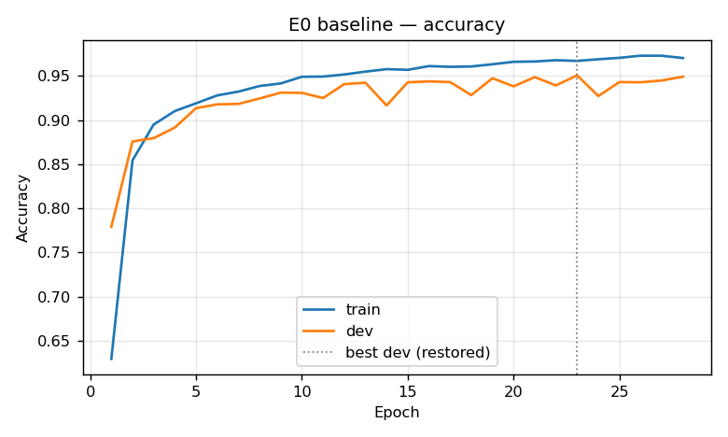
Figure 7.2 — E0 training and dev accuracy per epoch.

7.2 Per-class Performance
Table 7.2 — E0 per-class test metrics
Class | Name | Test support | Precision | Recall | F1
0 | Speed limit 20 | 60 | 0.973 | 0.600 | 0.742
1 | Speed limit 30 | 720 | 0.901 | 0.887 | 0.894
2 | Speed limit 50 | 750 | 0.819 | 0.917 | 0.865
3 | Speed limit 60 | 450 | 0.957 | 0.840 | 0.895
4 | Speed limit 70 | 660 | 0.925 | 0.856 | 0.889
5 | Speed limit 80 | 630 | 0.718 | 0.871 | 0.787
6 | End speed limit 80 | 150 | 0.958 | 0.607 | 0.743
7 | Speed limit 100 | 450 | 0.887 | 0.851 | 0.868
8 | Speed limit 120 | 450 | 0.907 | 0.802 | 0.851
9 | No passing | 480 | 0.950 | 0.992 | 0.970
10 | No passing >3.5t | 660 | 0.966 | 0.948 | 0.957
11 | Right-of-way at intersection | 420 | 0.888 | 0.948 | 0.917
12 | Priority road | 690 | 0.979 | 0.938 | 0.958
13 | Yield | 720 | 0.966 | 0.994 | 0.980
14 | Stop | 270 | 0.977 | 0.933 | 0.955
15 | No vehicles | 210 | 0.935 | 0.895 | 0.915
16 | No vehicles >3.5t | 150 | 0.980 | 0.973 | 0.977
17 | No entry | 360 | 0.969 | 0.964 | 0.967
18 | General caution | 390 | 0.937 | 0.651 | 0.769
19 | Dangerous curve left | 60 | 0.600 | 0.700 | 0.646
20 | Dangerous curve right | 90 | 0.738 | 0.689 | 0.713
21 | Double curve | 90 | 0.497 | 0.856 | 0.629
22 | Bumpy road | 120 | 0.882 | 0.875 | 0.879
23 | Slippery road | 150 | 0.813 | 0.813 | 0.813
24 | Road narrows on right | 90 | 0.782 | 0.756 | 0.768
25 | Road work | 480 | 0.952 | 0.863 | 0.905
26 | Traffic signals | 180 | 0.622 | 0.722 | 0.668
27 | Pedestrians | 60 | 0.568 | 0.417 | 0.481
28 | Children crossing | 150 | 0.763 | 0.860 | 0.809
29 | Bicycles crossing | 90 | 0.776 | 0.922 | 0.843
30 | Beware of ice/snow | 150 | 0.660 | 0.633 | 0.646
31 | Wild animals crossing | 270 | 0.665 | 0.830 | 0.738
32 | End of all limits | 60 | 0.841 | 0.967 | 0.899
33 | Turn right ahead | 210 | 0.912 | 0.986 | 0.947
34 | Turn left ahead | 120 | 0.868 | 0.983 | 0.922
35 | Ahead only | 390 | 0.984 | 0.974 | 0.979
36 | Go straight or right | 120 | 0.983 | 0.950 | 0.966
37 | Go straight or left | 60 | 0.980 | 0.800 | 0.881
38 | Keep right | 690 | 0.984 | 0.955 | 0.969
39 | Keep left | 90 | 0.935 | 0.956 | 0.945
40 | Roundabout mandatory | 90 | 0.924 | 0.944 | 0.934
41 | End of no passing | 60 | 0.534 | 0.650 | 0.586
42 | End of no passing >3.5t | 90 | 0.674 | 0.689 | 0.681
 | Macro average | 12630 | 0.849 | 0.843 | 0.841

Table 7.3 — Ten weakest classes by F1 (E0)
Rank | Class | Name | F1 | Train images | Test support
1 | 27 | Pedestrians | 0.481 | 219 | 60
2 | 41 | End of no passing | 0.586 | 221 | 60
3 | 21 | Double curve | 0.629 | 296 | 90
4 | 19 | Dangerous curve left | 0.646 | 187 | 60
5 | 30 | Beware of ice/snow | 0.646 | 413 | 150
6 | 26 | Traffic signals | 0.668 | 532 | 180
7 | 42 | End of no passing >3.5t | 0.681 | 211 | 90
8 | 20 | Dangerous curve right | 0.713 | 325 | 90
9 | 31 | Wild animals crossing | 0.738 | 693 | 270
10 | 0 | Speed limit 20 | 0.742 | 180 | 60

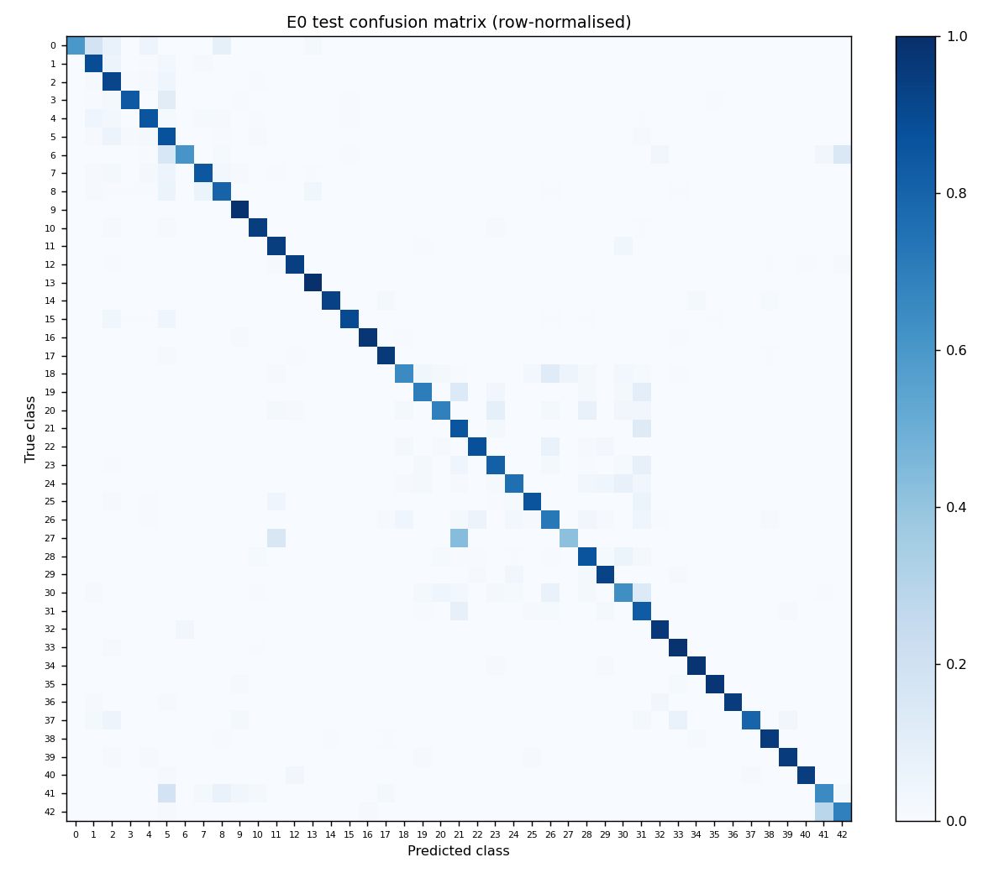
Figure 7.3 — E0 43×43 test confusion matrix, each row normalised by the class's test support.
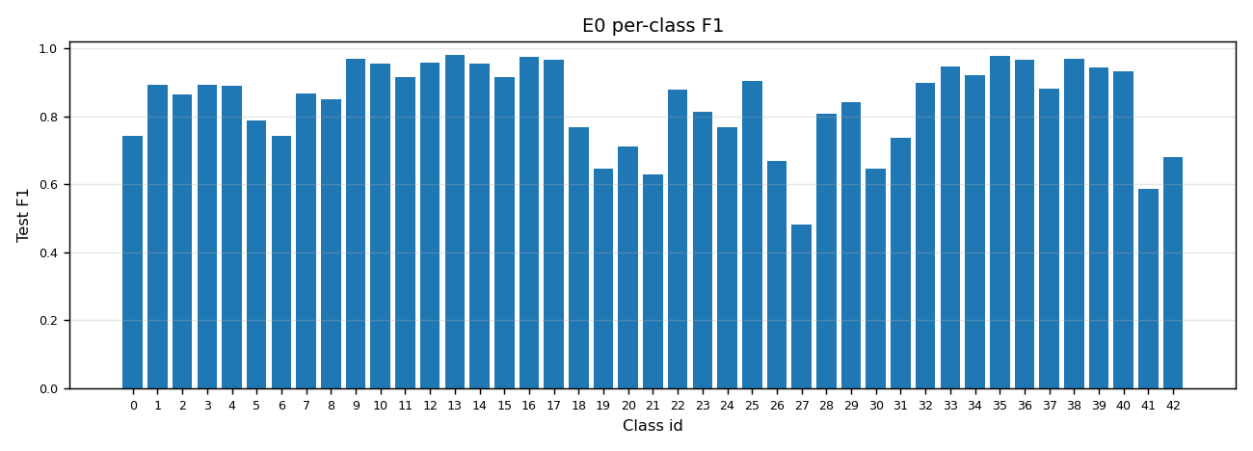
Figure 7.4 — E0 per-class test F1.
Correlation between class support and F1: Pearson r = 0.46, Spearman ρ = 0.49 (43 classes; support = training images per class). The correlation is positive and moderate. Rare classes are over-represented among the weak ones (eight of the ten weakest classes have fewer than 420 training images), but support explains only about a fifth of the variance in F1 (r² ≈ 0.21). Class 0 (Speed limit 20, 180 training images) is weak, yet Class 41 (221 images) is weak too while Class 37 (187 images) scores 0.881. The weak classes are rare and visually close to another class. Class weighting alone would not close the gap.
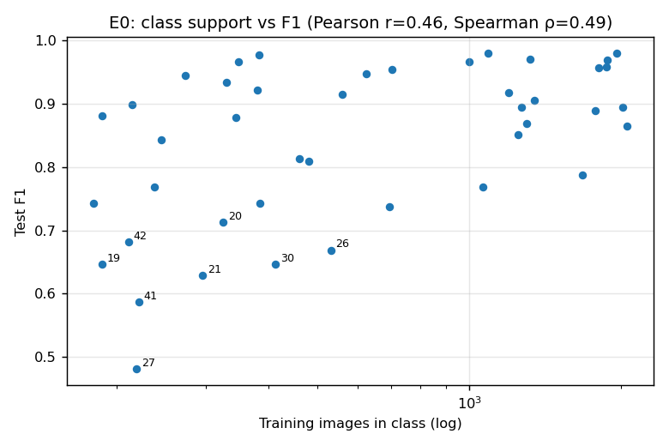
Figure 7.5 — Training images per class against test F1 (log x-axis). The eight weakest classes are labelled.

7.3 Most Frequent Confusions
Table 7.4 — Ten most frequent confused pairs (E0, test set)
Count | True class | Predicted class | Plausible cause
50 | 3 Speed limit 60 | 5 Speed limit 80 | Speed limits differ only in the digits; '6' and '8' are near-identical at 32×32
46 | 18 General caution | 26 Traffic signals | Same red triangle; the '!' and the traffic-light pictogram are both vertical strokes
42 | 1 Speed limit 30 | 2 Speed limit 50 | Digit confusion, '3' and '5'
36 | 5 Speed limit 80 | 2 Speed limit 50 | Digit confusion, '8' and '5'
35 | 2 Speed limit 50 | 5 Speed limit 80 | Digit confusion, '5' and '8'
28 | 4 Speed limit 70 | 1 Speed limit 30 | Digit confusion, '7' and '3'
27 | 8 Speed limit 120 | 7 Speed limit 100 | Digit confusion, '120' and '100' — the same number of glyphs
26 | 42 End of no passing >3.5t | 41 End of no passing | Same diagonal-bar design; differs only in the small lorry and car pictogram
26 | 27 Pedestrians | 21 Double curve | Same red triangle; low-resolution central pictogram
25 | 25 Road work | 31 Wild animals crossing | Same red triangle; dark central pictogram of similar mass

The expected pattern holds. Of the 1458 test errors, 630 (43%) have a true class among the speed limits (0–8), and 493 of those are predicted as another class in the same group. 540 errors (37%) have a true class among the triangular warning signs (18–31), and 468 of those stay within that group. Together the two groups account for 80% of all errors and supply nine of the ten pairs in Table 7.4. The blue circular mandatory signs (33–40) cause only 73 errors in total.
Table 7.5 — E0 test accuracy by original sign size and by sharpness
Slice | Images | Accuracy
Sign ROI 0–30 px (√(w·h)) | 5576 | 81.29%
Sign ROI 30–40 px (√(w·h)) | 2714 | 93.70%
Sign ROI 40–50 px (√(w·h)) | 1623 | 95.13%
Sign ROI 50–70 px (√(w·h)) | 1621 | 95.99%
Sign ROI 70–max px (√(w·h)) | 1096 | 90.88%
Sharpness quartile 1 (blurriest) | 3158 | 80.62%
Sharpness quartile 2 (middle) | 3157 | 89.36%
Sharpness quartile 3 (middle) | 3157 | 89.64%
Sharpness quartile 4 (sharpest) | 3158 | 94.21%

The median sign ROI side is 23 px for misclassified images against 33 px for correctly classified ones. Sharpness is the variance of the Laplacian on the preprocessed 32×32 image. It is a proxy: small signs are upsampled and therefore also blurrier, so the two measures are not independent.
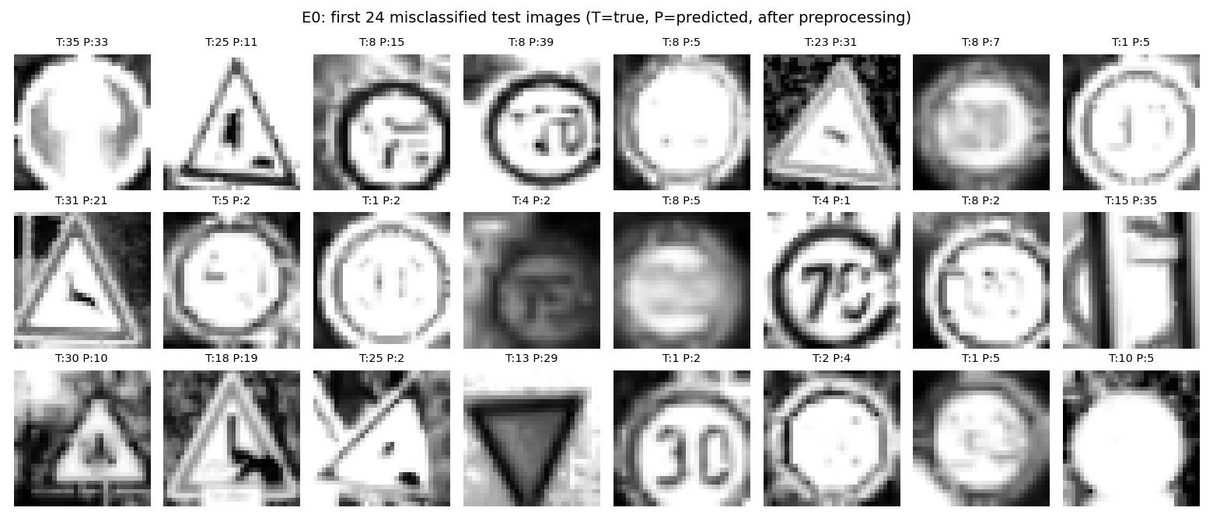
Figure 7.6 — The first 24 misclassified test images after preprocessing (T = true class, P = predicted class).

7.4 Ablation Results
Each table varies one factor from E0. "Epochs run" counts the epochs before early stopping, with the restored best-dev epoch in brackets. The train–dev gap is measured at the restored epoch. One seed per condition, so the tables report single values, not mean ± sd.
Table 7.6 — Initialization (E1)
Condition | Macro-F1 | Test acc. | Best dev acc. | Epochs run | Train–dev gap | Train time
He (E0) | 0.841 | 88.46% | 95.08% | 28 (best 23) | +1.63 pp | 2 min 50 s
Random ×0.01 | 0.845 | 88.40% | 95.00% | 40 (best 35) | +2.53 pp | 5 min 06 s

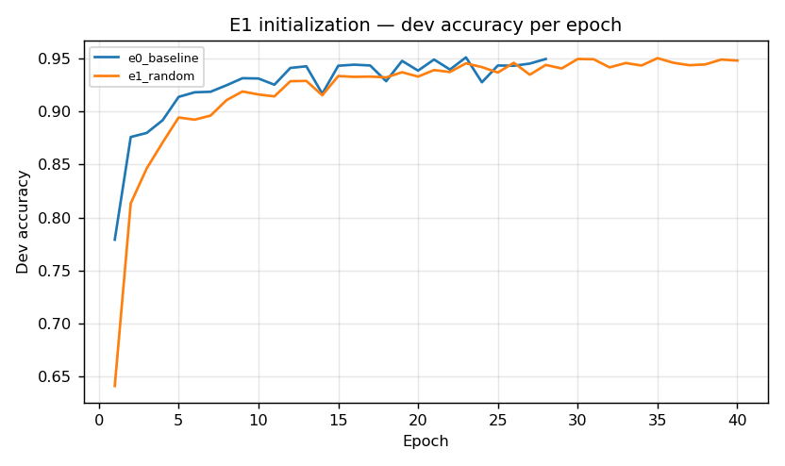
Figure 7.7a — E1: dev accuracy per epoch.
Table 7.7 — Optimizer (E2)
Condition | Macro-F1 | Test acc. | Best dev acc. | Epochs run | Train–dev gap | Train time
Adam (E0) | 0.841 | 88.46% | 95.08% | 28 (best 23) | +1.63 pp | 2 min 50 s
Mini-batch GD | 0.534 | 70.28% | 73.29% | 40 (best 40) | +1.24 pp | 2 min 20 s
Batch GD | 0.001 | 0.70% | 1.02% | 8 (best 3) | -0.30 pp | 25 s

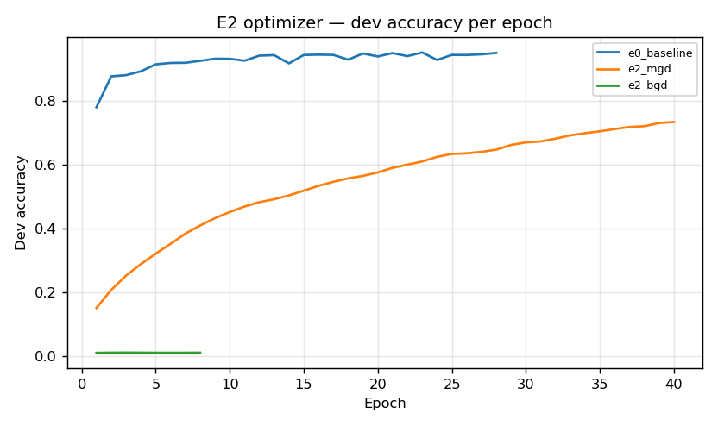
Figure 7.7b — E2: dev accuracy per epoch.
Table 7.8 — Regularization (E3)
Condition | Macro-F1 | Test acc. | Best dev acc. | Epochs run | Train–dev gap | Train time
Dropout p=0.6 | 0.846 | 88.17% | 93.29% | 31 (best 26) | +0.81 pp | 3 min 32 s
Dropout p=0.7 | 0.862 | 89.24% | 94.97% | 33 (best 28) | +1.08 pp | 3 min 51 s
Dropout p=0.8 (E0) | 0.841 | 88.46% | 95.08% | 28 (best 23) | +1.63 pp | 2 min 50 s
Dropout p=0.9 | 0.853 | 88.59% | 94.74% | 21 (best 16) | +1.88 pp | 1 min 55 s
L2 λ=0.1 | 0.829 | 86.71% | 93.37% | 18 (best 13) | +1.26 pp | 1 min 38 s
L2 λ=0.4 | 0.816 | 85.17% | 91.30% | 15 (best 10) | -0.13 pp | 1 min 22 s
L2 λ=0.7 | 0.800 | 84.82% | 89.46% | 11 (best 6) | -0.96 pp | 1 min 00 s
L2 λ=1.0 | 0.777 | 83.94% | 88.11% | 11 (best 6) | -1.41 pp | 1 min 00 s
None | 0.841 | 86.98% | 94.80% | 25 (best 20) | +2.72 pp | 2 min 10 s

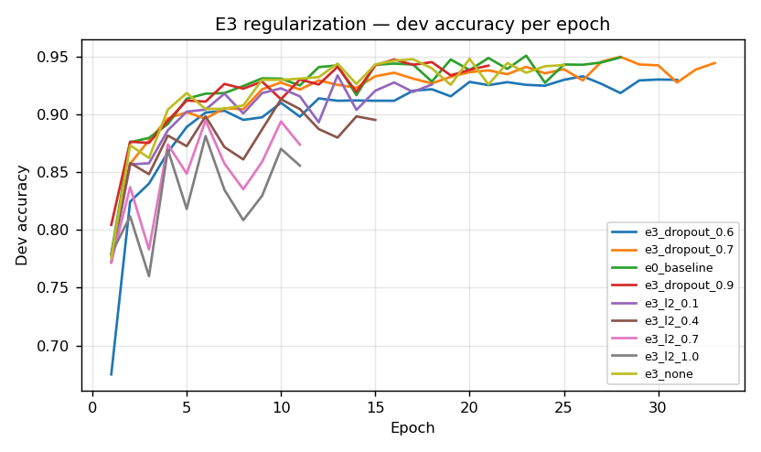
Figure 7.7c — E3: dev accuracy per epoch.
Table 7.9 — Architecture (E4)
Condition | Macro-F1 | Test acc. | Best dev acc. | Epochs run | Train–dev gap | Train time | Params
[256] | 0.837 | 87.52% | 93.60% | 21 (best 16) | +1.44 pp | 51 s | 273,451
[512, 256] (E0) | 0.841 | 88.46% | 95.08% | 28 (best 23) | +1.63 pp | 2 min 50 s | 667,179
[1024, 512, 256] | 0.842 | 87.56% | 93.70% | 17 (best 12) | +1.13 pp | 3 min 54 s | 1,716,779
[1024, 512, 256, 128] | 0.857 | 88.96% | 94.67% | 34 (best 29) | +1.53 pp | 10 min 58 s | 1,744,171

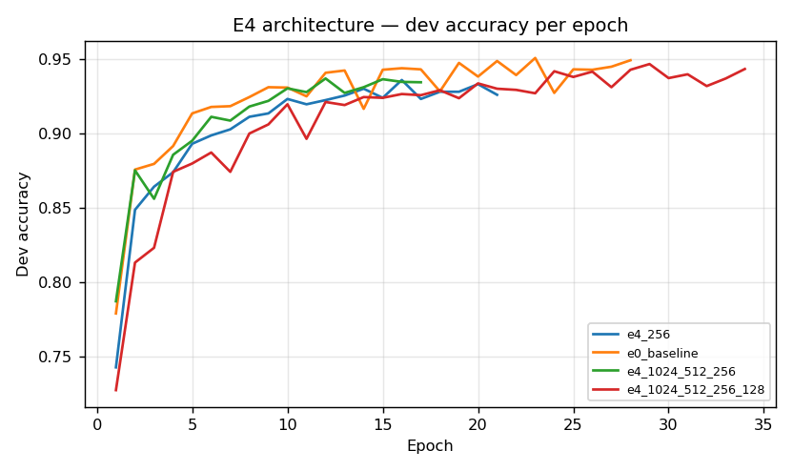
Figure 7.7d — E4: dev accuracy per epoch.
Table 7.10 — Augmentation (E5)
Condition | Macro-F1 | Test acc. | Best dev acc. | Epochs run | Train–dev gap | Train time
Original data (E0) | 0.841 | 88.46% | 95.08% | 28 (best 23) | +1.63 pp | 2 min 50 s
+ 5 augmented variants (6×) | 0.873 | 90.93% | 96.76% | 25 (best 20) | -2.03 pp | 25 min 36 s

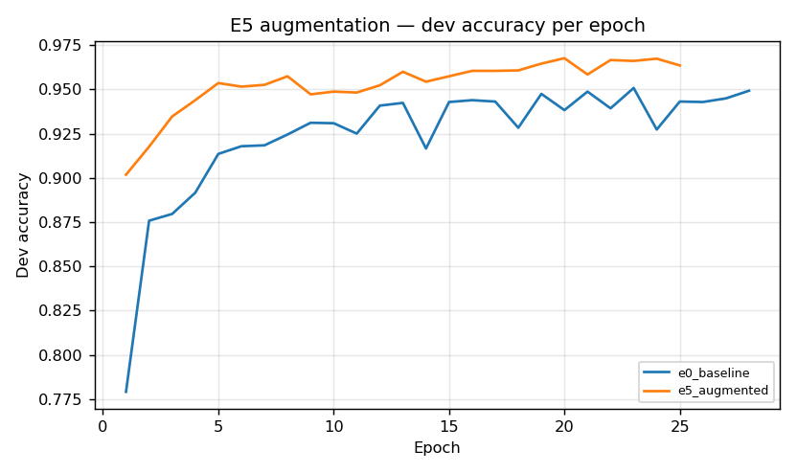
Figure 7.7e — E5: dev accuracy per epoch.
E5 run note. augment.py wrote 176,445 augmented examples (5 per training image) in 41 s, peaking at 4.4 GB of memory. The unmodified train.py --use-augmented was then killed by the out-of-memory killer after 37 s, at 5.8 GB RSS on the 8 GB machine. The float64 augmented matrix (1.45 GB), its concatenation with the original data (1.73 GB), and the per-epoch shuffled copy are all alive at the same time. E5 was therefore run through experiments/train_lowmem.py, a wrapper that holds the input matrices as float32. Weights and all arithmetic stay float64, and nothing in src/ changes. Peak RSS was 3.5 GB.
Mean per-class F1 change from E0 to E5: +0.037 for the 19 rare classes (<420 training images), +0.029 for the 24 others.
Table 7.11 — Learning-rate decay (E6)
Condition | Macro-F1 | Test acc. | Best dev acc. | Epochs run | Train–dev gap | Train time
Constant lr (E0) | 0.841 | 88.46% | 95.08% | 28 (best 23) | +1.63 pp | 2 min 50 s
Step decay every 10 epochs | 0.856 | 89.21% | 96.07% | 34 (best 29) | +1.43 pp | 3 min 59 s

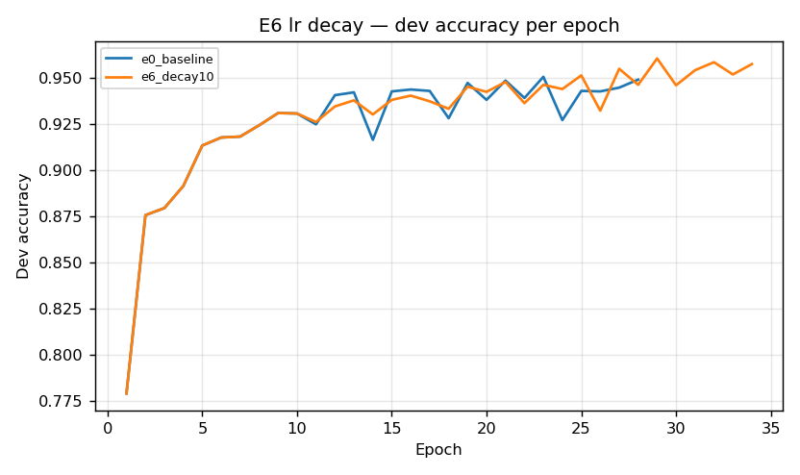
Figure 7.7f — E6: dev accuracy per epoch.

7.5 Calibration, Inference Cost and Resources
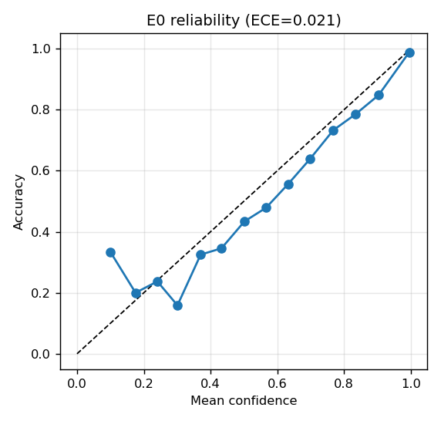
Figure 7.8 — E0 reliability diagram on the test set (15 equal-width confidence bins).
Table 7.12 — Rejecting low-confidence predictions (E0, test set)
Confidence threshold | Images accepted | Accuracy on accepted | Errors rejected | Correct predictions rejected
0.500 | 92.5% | 93.17% | 45.3% | 2.5%
0.700 | 86.1% | 96.25% | 72.0% | 6.3%
0.800 | 82.5% | 97.36% | 81.1% | 9.2%
0.900 | 77.7% | 98.42% | 89.4% | 13.5%

Inference for E0 (667,179 parameters) was timed separately on the idle machine with experiments/inference_timing.py. The timings cover the forward pass on already-preprocessed input, and exclude image decoding and preprocessing. A batched pass over all 12,630 test images took a median of 0.18 s over 7 repeats, or 14.3 µs per image. Classifying one image at a time took a median of 154 µs (95th percentile 195 µs, 1,000 images), because per-call overhead dominates a network this small. Either figure is far below a camera frame interval. Training memory peaked at 1141 MB for E0, higher than the 816 MB estimated in Section 5.1. The difference is interpreter, NumPy and cached-dataset overhead on top of the design matrix.

8. Discussion
Sections 8.1–8.3 interpret the results in Section 7. Section 8.4 is an architectural analysis that holds regardless of the runs.

8.1 Baseline Interpretation
The baseline reaches 88.46% top-1 test accuracy and a macro-F1 of 0.841. The 4.4-point gap between the two means per-class performance is uneven: common classes such as Priority road, Yield, Keep right and No entry score F1 above 0.95, and the classes in Table 7.3 score between 0.48 and 0.74. Accuracy is weighted by the common classes and hides this, which is why macro-F1 is the headline metric.
Measured on the dev split, the model looks well fitted: at the restored epoch the training–dev gap is only 1.63 points, and dev loss flattens from about epoch 12 while training loss keeps falling. The dev split flatters the model, though. Best dev accuracy is 95.08% but test accuracy is 88.46% — a drop of 6.62 points that no dev-side measure predicts. This is the bias anticipated in Section 9.3: random 90/10 splitting puts frames of the same physical sign in both the training and dev partitions, so dev accuracy partly measures recognition of near-duplicates. On the track-disjoint test set the model generalises less well than the dev curve suggests. The limiting factor is generalisation to new physical signs, not optimisation.
Early stopping triggered at epoch 28, restoring epoch 23, so the 40-epoch budget was not binding for Adam. Only E1 (random initialisation) and E2-MGD used the full budget, and only E2-MGD was still improving at the end.
Calibration is good. Mean confidence is 0.950 on correct predictions and 0.558 on incorrect ones, and the 15-bin expected calibration error is 0.021. The score is usable as a rejection signal (Section 6.5): Table 7.12 shows that rejecting predictions below 0.7 confidence would catch 72% of the errors, at the cost of 6.3% of the correct predictions, and raise accuracy on the accepted 86% of images to 96.2%.

8.2 Ablation Interpretation
E1 — initialization. He initialisation made no difference to the final result: test accuracy was 88.46% for He and 88.40% for random, and macro-F1 was 0.841 against 0.845. It did speed up training. He reached its best dev accuracy at epoch 23, while random initialisation kept improving until epoch 35 and used the whole budget. Figure 7.7a shows the random run starting lower and catching up. With only two hidden layers, Adam's per-parameter step sizes largely compensate for the poor scale of a ×0.01 initialisation. He initialisation matters more in deeper networks and without an adaptive optimiser.
E2 — optimizer. Adam's advantage is large, and within the 40-epoch budget it did not go away. Plain mini-batch gradient descent at the same learning rate reached only 70.28% test accuracy and a macro-F1 of 0.534 after all 40 epochs, and its dev accuracy was still rising. It is under-trained rather than converged to a worse optimum, and a larger learning rate would narrow the gap. Batch gradient descent failed completely (0.70%): one update per epoch meant only 8 gradient steps before early stopping, against 7,728 in E0's 28 epochs. Its loss was falling steadily (4.26 → 4.10 in the log). Under an epoch budget, BGD is handicapped by the number of updates it gets, not by the quality of its gradients. Early stopping on dev accuracy with a patience of 5 is also inappropriate for it. BGD also used the most memory of any E0–E4 run (3.0 GB), because it forward-propagates all 35k examples at once.
E3 — regularization. Dropout beat L2 at every setting tried. Dropout with p = 0.7 was the best single configuration among the E3 settings and second only to augmentation overall (89.24% test accuracy, macro-F1 0.862). The dropout results form a shallow optimum: p = 0.6 over-regularises slightly, and p = 0.8 and 0.9 regularise less. The spread (0.841–0.862 macro-F1) is close to seed noise. L2 got worse as λ increased, from macro-F1 0.829 at λ = 0.1 to 0.777 at λ = 1.0. At λ ≥ 0.4 the training–dev gap turns negative and early stopping fires by epoch 15, the signature of underfitting. The implementation divides λ by the mini-batch size (128), not the training-set size, so the λ grid carried over from the MNIST project applies much stronger decay than its values suggest, and should be moved down by one to two orders of magnitude. With no regularization the network overfits most (a gap of 2.72 points) and reaches 86.98%. Overall the network has more than enough capacity for this data, and the most effective regulariser was dropout, which also averages over sub-networks.
E4 — depth and width. Performance hardly changes with size. The four architectures span 0.837–0.857 macro-F1 while the parameter count grows from 273k to 1.74M. The deepest network, [1024, 512, 256, 128], scored highest (0.857). The three-hidden-layer [1024, 512, 256] was cut off by early stopping at epoch 17 and scored about the same as the baseline and the smallest network, [256]. There is no clear turnover point. Any real trend is smaller than single-seed noise, which is consistent with Section 8.4: extra parameters do not give a fully connected network the translation invariance it lacks. The deepest network cost nearly four times the baseline's training time for half a point of accuracy (1.6 points of macro-F1).
E5 — augmentation. Training on the original data plus five augmented variants per image moved test accuracy from 88.46% to 90.93% and macro-F1 from 0.841 to 0.873 (+3.25 points). The mean per-class F1 change was +0.037 for the rare classes and +0.029 for the others: slightly larger for the rare classes, in the direction predicted, but not sharply concentrated there. Shift, rotation, zoom, blur and crop-and-pad give the network the positional variation it cannot infer on its own (Section 8.4), which is the most direct compensation for its missing translation invariance available within this architecture. Augmentation was the most expensive intervention: 25 min 36 s of training against 2 min 50 s for E0, and 3.5 GB of memory even with float32 inputs.
E6 — learning-rate decay. E6 scored 0.856 macro-F1 against 0.841 for the baseline, but the difference cannot be credited to decay. The schedule barely decays at all. The run log shows the learning rate going from 0.001000 to 0.000965, 0.000931 and 0.000898 at epochs 11, 21 and 31, a total cut of about 10%. In train() the decay rate is set to lr / ((i+1)/N), which is tiny when lr is 0.001, and learning_rate_schedule then applies lr / (1 + decay_rate·epoch). Because both runs share seed 1, E0 and E6 are identical for the first 10 epochs and only diverge after the first 3.5% cut. So the difference is the effect of a small perturbation on the training trajectory: in practice a different random draw, at the scale of seed noise, not evidence that decay helps. A meaningful E6 needs a schedule that actually decays, for example halving every 10 epochs.

8.3 Error Analysis
The confusions are concentrated where Section 7.3 predicted. Speed limits and triangular warning signs account for 80% of test errors, and most of those errors stay within the group: the network recognises the sign family and misreads the pictogram. Among the speed limits, the digit pairs 6/8, 3/5, 5/8, 7/3 and 120/100 dominate. At 32×32 grayscale these digits are separated by a handful of pixels, and a fully connected layer has no local-feature detectors to pick those pixels out. Among the triangles, the model confuses pictograms that are thin vertical strokes (General caution → Traffic signals, 46 errors) or dark blobs of similar mass (Road work → Wild animals, Pedestrians → Double curve). Traffic signals versus General caution is also a case where colour would help: the red, amber and green lamps are lost in grayscale (Section 9.1).
The misclassified images share one clear property: they are small. Accuracy is 81.3% for signs under 30 px across, which is 44% of the test set, against 93.7%–96.0% for signs of 30–70 px. The median misclassified sign is 23 px against 33 px for correct ones. These signs are upsampled to 32×32 and lose detail, and the blurriest quartile by Laplacian variance has 80.6% accuracy against 94.2% for the sharpest. Accuracy falls again for the largest signs (90.9% above 70 px). These are close-range frames, probably with stronger perspective distortion, although this was not measured. Figure 7.6 shows the recurring visual failure modes: sign interiors washed out by histogram equalisation until the digits nearly vanish, heavy blur, and signs that are off-centre or cut off by the ROI crop.
Top-2 accuracy is 92.76% against 88.46% for top-1, so the correct class is the runner-up for 4.31% of all test images, about 37% of the errors. The largest gains are in exactly the confusable classes: End of no passing >3.5t (69% → 89%), Speed limit 20 (60% → 73%), Wild animals crossing (83% → 95%), General caution (65% → 76%), Traffic signals (72% → 82%). For these classes the network has narrowed the answer to two look-alikes but ranks them the wrong way round. That is a sign the discriminating detail is present but weakly encoded, so higher resolution or colour input would help them most.

8.4 The Architectural Ceiling (Analysis, Independent of Results)
The dominant limitation is structural, and worth stating precisely because it is the whole reason this architecture underperforms the state of the art.
No translation invariance. A fully connected layer assigns an independent weight to each input coordinate. Input pixel 100 and input pixel 101 are, to the network, unrelated variables — the fact that they are horizontally adjacent is information the architecture cannot represent. A sign shifted three pixels right is a substantially different input vector, and the network must learn its appearance separately at every position it can occupy. Convolutional networks solve this by weight sharing: one learned filter is applied at every position, so a feature learned at one location transfers to all others for free.
No spatial locality. Every hidden unit in layer 1 sees all 1,024 inputs at once. There is no architectural pressure towards local features — edges, corners, strokes — that compose into larger structures. The hierarchical composition that makes CNNs sample-efficient on images is unavailable.
The consequence is sample efficiency, not capacity. By the universal approximation theorem [5], the network could represent a good classifier. It would need vastly more data to find one, because it must learn from examples what a convolutional architecture is given by construction. Section 2.1 shows the empirical size of the gap: 99.46% for a CNN committee against 95.68% for classical LDA on HOG features, with an MLP on raw pixels expected below the latter.
This is a well-understood limitation and the reason the field moved to convolutional architectures for vision. Documenting it precisely is more useful than obscuring it.

9. Limitations and Threats to Validity

9.1 Grayscale Conversion Discards Regulatory Colour
German traffic signs encode meaning in colour by regulation: red borders for prohibitory, blue for mandatory, yellow for temporary. Grayscale conversion discards this. The trade-off was taken to keep the input dimension at 1,024 (Section 4.2), and Sermanet and LeCun [3] report the cost on GTSRB is modest — but it is a cost, and it is likely concentrated exactly where colour is the main discriminant between otherwise similar shapes.

9.2 Recognition, Not Detection
The system classifies images that already contain one cropped, centred sign, using ROI annotations supplied by the benchmark. A deployed system must first find signs in a full scene. This is a distinct problem requiring a detector, and no part of it is addressed here. Reported accuracy therefore describes only the classification stage of a hypothetical pipeline.

9.3 Dev Split Is Not Track-Disjoint
As noted in Section 3.2, GTSRB contributes 30 consecutive frames per physical sign. The random 90/10 dev split places frames of the same physical sign on both sides, so dev accuracy is optimistically biased — the model has seen near-duplicates of its validation images. This affects early stopping, which may halt later than a clean split would justify. The official test partition is track-disjoint and unaffected, so reported test figures remain sound. A track-aware split is the correct fix and is listed in Section 10.2.
Measured effect. In the Section 7 runs this bias is large. Best dev accuracy exceeded test accuracy by 6.6 points for E0, and by 4.2–7.8 points across every configuration that trained properly (Section 8.1). Early stopping and every dev-based comparison inherit this bias. The test figures do not.

9.4 Class Imbalance Is Uncorrected
No class weighting, oversampling or loss reweighting is applied. The 10.7:1 imbalance is passed through to training as-is. This is why macro-F1 rather than accuracy is the headline metric — the metric reveals the problem rather than solving it.

9.5 Single-Seed Results if Not Repeated
Differences of a percentage point or so between configurations are not reliably distinguishable from initialization noise. The protocol calls for ≥3 seeds with mean and standard deviation; conclusions drawn from single runs should be treated as provisional.
Applies to this report. Every figure in Section 7 comes from a single run with seed 1, so the ablation conclusions in Section 8.2 are provisional. The exceptions are E2 and L2-regularised E3, whose effects are far larger than seed noise.

9.6 Fixed Preprocessing Is Not Ablated
The five preprocessing steps are held constant across all experiments and justified by argument rather than measurement. The contribution of histogram equalization in particular — argued in Section 4.2 to be the highest-value step — is untested. An ablation over preprocessing would strengthen this.

9.7 Occlusion and Physical Degradation Unaddressed
Neither the preprocessing nor the augmentation models partial occlusion, fading, or vandalism, all of which occur in the test set. No augmentation transformation simulates them, and performance on affected images is uncharacterised.

9.8 Inference Latency Measured for the Forward Pass Only
Inference was measured for E0 (Section 7.5). A forward pass took 14.3 µs per image in a batch and 154 µs for a single image (median; 95th percentile 195 µs) on two cores. This is still not an end-to-end figure: decoding, the ROI crop and the preprocessing of Section 4.2 are excluded, and in a deployed system the sign would first have to be detected (Section 9.2).

10. Conclusion and Future Work

10.1 Conclusion
This report presented a traffic sign classifier for GTSRB built on a feed-forward neural network implemented entirely from first principles in NumPy. Forward propagation, backpropagation, Adam, inverted dropout, L2 regularization, He initialization and early stopping were each derived and implemented directly, with no machine learning framework.
The methodological contributions stand independently of the training results. A preprocessing pipeline was designed with each stage justified against a specific property of the data. Augmentation transformations inherited from the digit domain were re-examined and found partly invalid, with horizontal mirroring identified as label-corrupting for eight directional sign classes. Three defects in the antecedent codebase were found and corrected, two of them silent. A controlled protocol of six ablations was specified, and the resource profile of the training procedure was measured.
Measured on the GTSRB test set, the baseline network reaches 88.46% top-1 accuracy (92.76% top-2) and a macro-F1 of 0.841. The best configuration tested, the augmented training set (E5), reaches 90.93% and macro-F1 0.873. Both are well below the reference points in Section 2.1. The baseline is about 7 points below LDA on HOG features (95.68%) and 11 points below the winning CNN committee (99.46%), and the best configuration narrows the first gap only to about 5 points. This is the position the architectural analysis predicted. The errors have the structure Section 8.4 predicts for a network without spatial priors: they concentrate within sign families that differ only in a small interior pictogram, and in small, low-resolution images.
Three ablations produced effects clearly larger than seed noise. For the optimizer (E2), Adam against plain gradient descent at the same learning rate is the difference between a working and a non-working model within 40 epochs. Augmentation (E5) gave the largest gain, +3.2 points of macro-F1 and +2.5 points of accuracy. L2 regularization at the planned strengths hurt clearly, because the implementation scales λ by the mini-batch size. He initialization sped up convergence without changing the final result. Dropout rate, depth, width and the (nearly inactive) learning-rate schedule changed macro-F1 by at most about two points, which one seed cannot separate from noise. The study also exposed a methodological point: in every configuration that trained properly, best dev accuracy overstated test accuracy by 4.2–7.8 points (6.6 for E0), which quantifies the track-leakage bias in Section 9.3 and makes a track-aware dev split the most important protocol fix.

10.2 Future Work

Immediate, within this architecture
- Track-aware dev split, removing the bias identified in Section 9.3.
- Class-imbalance correction — weighted loss or targeted oversampling of the rare classes — with macro-F1 as the measure of success.
- Preprocessing ablation, in particular quantifying histogram equalization.
- Colour input: retain RGB at 3,072 features and measure whether the accuracy gain justifies tripling the first layer.
- End-to-end inference latency benchmark: forward-pass latency is now measured (Section 7.5), but the full path from camera frame to label, including preprocessing, is not (Section 9.8).
Implementation fixes found by the ablations. Two defects surfaced in Section 8.2 and should be fixed before the ablations are repeated. First, the L2 term divides λ by the mini-batch size, so the planned λ grid over-regularises heavily. Second, the step-decay schedule set up in train() cuts the learning rate by only about 10% in total, which makes E6 almost a no-op. The augmented-data path should also keep its design matrix in float32 (Section 7.4). Finally, every ablation should be repeated with at least three seeds, as the protocol requires.

Architectural
- Convolutional layers. The principled fix for both deficits in Section 8.4. src/dataset.py feeds a CNN unchanged — omit flatten_input. This is the single highest-value change available.
- Batch normalisation, to stabilise training in deeper configurations.
- Ensembling, following the approach that won the original benchmark [2].

Beyond classification
- Detection, converting recognition into a system usable on street scenes.
- Temporal aggregation over the 30-frame tracks, since a deployed system sees a sequence and can accumulate evidence rather than deciding per frame.

References
[1] J. Stallkamp, M. Schlipsing, J. Salmen, and C. Igel, “Man vs. computer: Benchmarking machine learning algorithms for traffic sign recognition,” Neural Networks, vol. 32, pp. 323–332, 2012.
[2] D. Cireşan, U. Meier, J. Masci, and J. Schmidhuber, “Multi-column deep neural network for traffic sign classification,” Neural Networks, vol. 32, pp. 333–338, 2012.
[3] P. Sermanet and Y. LeCun, “Traffic sign recognition with multi-scale convolutional networks,” in Proc. IJCNN, 2011, pp. 2809–2813.
[4] N. Dalal and B. Triggs, “Histograms of oriented gradients for human detection,” in Proc. CVPR, 2005, pp. 886–893.
[5] K. Hornik, M. Stinchcombe, and H. White, “Multilayer feedforward networks are universal approximators,” Neural Networks, vol. 2, no. 5, pp. 359–366, 1989.
[6] Y. LeCun, L. Bottou, Y. Bengio, and P. Haffner, “Gradient-based learning applied to document recognition,” Proc. IEEE, vol. 86, no. 11, pp. 2278–2324, 1998.
[7] K. He, X. Zhang, S. Ren, and J. Sun, “Delving deep into rectifiers: Surpassing human-level performance on ImageNet classification,” in Proc. ICCV, 2015, pp. 1026–1034.
[8] D. P. Kingma and J. Ba, “Adam: A method for stochastic optimization,” in Proc. ICLR, 2015.
[9] N. Srivastava, G. Hinton, A. Krizhevsky, I. Sutskever, and R. Salakhutdinov, “Dropout: A simple way to prevent neural networks from overfitting,” JMLR, vol. 15, no. 1, pp. 1929–1958, 2014.
[10] I. Goodfellow, Y. Bengio, and A. Courville, Deep Learning. MIT Press, 2016.

Dataset citation. J. Stallkamp, M. Schlipsing, J. Salmen, and C. Igel, “The German Traffic Sign Recognition Benchmark: A multi-class classification competition,” in Proc. IJCNN, 2011, pp. 1453–1460. Available: https://benchmark.ini.rub.de/gtsrb_dataset.html. Licensed CC BY 4.0.

Appendix A — Reproducibility
Environment. Dockerfile and docker-compose.yml pin the complete environment. See SETUP.md for both the container and native paths.

Reproducing the baseline from a clean checkout
docker build -t traffic-sign-detection .
docker compose run --rm tsd python train.py --epochs 40 --out models/e0_baseline
docker compose run --rm tsd python evaluate.py --model models/e0_baseline --no-plot
Seeding. np.random.seed(1) at entry to every script; --seed overrides. Given identical data and flags, runs reproduce.
Data provenance. GTSRB is downloaded from the URLs in GTSRB_URLS (src/dataset.py), which are the archives linked from the official benchmark page. Decoded arrays are cached as dataset/gtsrb/gtsrb_32.npz.
Runs reported in Section 7. experiments/run_all.sh <run-id> … trains and evaluates each configuration and writes logs to results/logs/. experiments/analyze.py builds results/summary.json, results/all_runs_summary.csv, the E0 per-class and confusion CSVs, and results/figures/. experiments/error_analysis.py writes results/e0_error_analysis.json. experiments/train_lowmem.py is the float32 wrapper used for E5, and experiments/inference_timing.py writes results/e0_inference_timing.json. Trained models are in models/. The preprocessed dataset cache (dataset/gtsrb/gtsrb_32.npz, SHA-256 bdbf50a8…a2523c) was built from the three official archives.

Code manifest
File | Role
src/dataset.py | Acquisition, decoding, preprocessing, splitting, encoding
src/ffnn.py | Network: initialization, forward, cost, backward, optimizers, training, prediction
src/model_utils.py | Activations, mini-batching, metrics, confusion matrix, plots, persistence
src/data_augmentation.py | Augmentation transformations and generator
train.py / evaluate.py / predict.py / augment.py / gui.py | Entry points
Project_Walkthrough.ipynb | Step-by-step executable walkthrough
README.md / SETUP.md | Overview and setup guide
experiments/ | Experiment runner, analysis and error-analysis scripts used for Section 7
results/ | Logs, metrics, CSVs and figures from the Section 7 runs

Appendix B — Class Index
Id | Class | Id | Class
0 | Speed limit 20 | 22 | Bumpy road
1 | Speed limit 30 | 23 | Slippery road
2 | Speed limit 50 | 24 | Road narrows on right
3 | Speed limit 60 | 25 | Road work
4 | Speed limit 70 | 26 | Traffic signals
5 | Speed limit 80 | 27 | Pedestrians
6 | End speed limit 80 | 28 | Children crossing
7 | Speed limit 100 | 29 | Bicycles crossing
8 | Speed limit 120 | 30 | Beware of ice/snow
9 | No passing | 31 | Wild animals crossing
10 | No passing >3.5t | 32 | End of all limits
11 | Right-of-way at intersection | 33 | Turn right ahead
12 | Priority road | 34 | Turn left ahead
13 | Yield | 35 | Ahead only
14 | Stop | 36 | Go straight or right
15 | No vehicles | 37 | Go straight or left
16 | No vehicles >3.5t | 38 | Keep right
17 | No entry | 39 | Keep left
18 | General caution | 40 | Roundabout mandatory
19 | Dangerous curve left | 41 | End of no passing
20 | Dangerous curve right | 42 | End of no passing >3.5t
21 | Double curve

The eight directional classes affected by the mirroring analysis in Section 4.9 are 19, 20, 33, 34, 36, 37, 38 and 39.

Appendix C — Notation
Symbol | Meaning
m | Number of examples in the current batch
L | Number of layers (hidden + output)
n⁽ˡ⁾ | Units in layer l; n⁽⁰⁾ = 1024, n⁽ᴸ⁾ = 43
X | Input matrix, (1024 × m)
Y | One-hot labels, (43 × m)
Ŷ | Predicted probabilities, (43 × m)
W⁽ˡ⁾, b⁽ˡ⁾ | Weights and biases of layer l
Z⁽ˡ⁾, A⁽ˡ⁾ | Pre-activation and activation of layer l
D⁽ˡ⁾ | Dropout mask for layer l
α, λ, p | Learning rate, L2 strength, dropout keep probability
β₁, β₂, ε | Adam hyperparameters
v_t, s_t | Adam first and second moment estimates at step t
J | Cost
⊙ | Element-wise (Hadamard) product

